6.1

Question: Describe a situation or problem from your job, everyday life, current events, etc., for which a Change Detection model would be appropriate. Applying the CUSUM technique, how would you choose the critical value and the threshold?

Answer:

At home I could use a change detection model to monitor my account balance vs time. Currently I do this manually by pulling my credit card statements, along with my checking account information. However, I could use the CUSUM technique to identify if I a large spend on my account in a given month allowing me to investigate if I made a large purchase or if it was related to fraud. I would choose the critical value and threshold by looking at my past data and testing different models against that data. This would allow me to identify the times when I wish I was notified vs false positives. Then these metrics could be carried forward into the future.

6.2.1

First imported the data into Excel

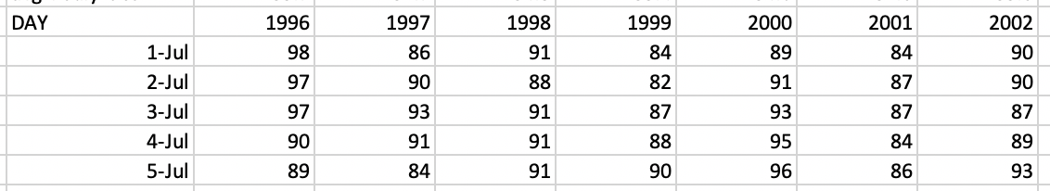

Then calculated St using the following formula/table:

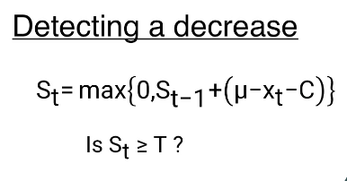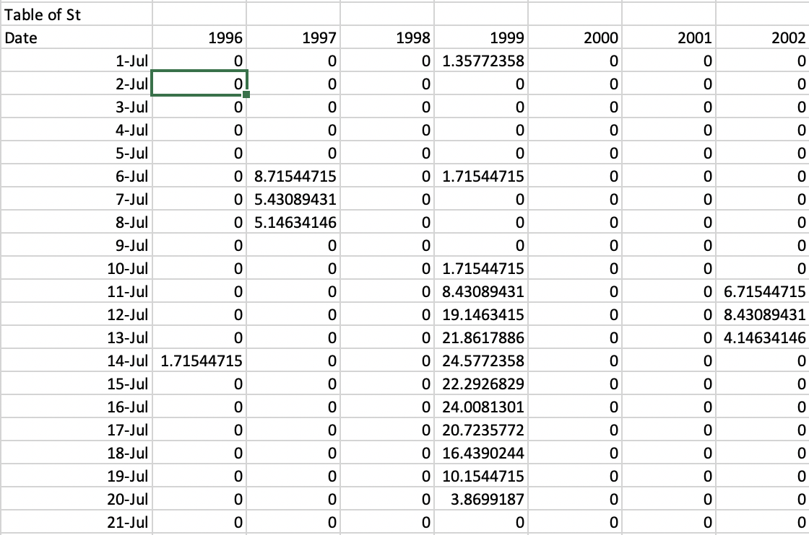

Now using this table pick a T value that will remove false positives



Difficult to see false positives from here so zoom in on Y axis.

Now From this chart the last false positive for the end of summer seems to be the Green line (2013).

Pick the Threshold Value of 55. I left the C value at 0.



Now pick the end of summer date based on this threshold value

T end of summer dates are summarized in the table below.

|  |  |
| --- | --- |
| Year | End of Summer |
| 1996 | 28-Sep |
| 1997 | 26-Sep |
| 1998 | 7-Oct |
| 1999 | 23-Sep |
| 2000 | 8-Sep |
| 2001 | 26-Sep |
| 2002 | 26-Sep |
| 2003 | 22-Sep |
| 2004 | 17-Sep |
| 2005 | 9-Oct |
| 2006 | 25-Sep |
| 2007 | 10-Oct |
| 2008 | 26-Sep |
| 2009 | 13-Sep |
| 2010 | 2-Oct |
| 2011 | 19-Sep |
| 2012 | 4-Oct |
| 2013 | 25-Sep |
| 2014 | 28-Sep |
| 2015 | 24-Sep |

Earliest, Median and Latest Date:

|  |  |
| --- | --- |
|  | End of Summer Date |
| Earliest | 8-Sep |
| Median | 26-Sep |
| Latest | 10-Oct |

6.2.2

I used two approaches for this part.

1. I used the Average of the temperatures from July-October for all years.
2. I used the average of the temperatures from July-End of summer date from 6.2.1

In both cases I observed a spikes in the warming of temperatures in 2006, 2010 and 2011. However, I don’t see the same continuous upward trend that we observe on the previous set of data. Potentially if we brought in additional data starting earlier in the century then we would not be anchored on the mean from the last 20 years.

Overall, I don’t believe there is a continuous warming trend over this period, however there are warning signs with the spikes in 2006, 10 and 11.

